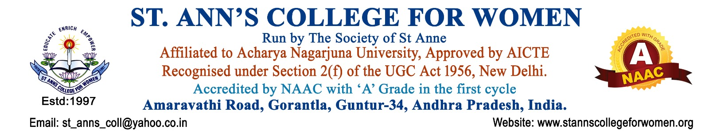

B.Sc Honours – Botany
Exploring Plant Sciences for a Sustainable Future
The B.Sc Honours – Botany programme at St. Ann’s College for Women provides in-depth knowledge of plant sciences, biodiversity, ecology, plant physiology, genetics, biotechnology, and environmental conservation. The programme develops scientific understanding, analytical skills, and practical laboratory experience essential for careers in research, agriculture, healthcare, and environmental sciences.
The combination of Botany Major with Food Science & Nutrition Minor offers interdisciplinary learning in nutrition, food safety, human health, food processing, medicinal plants, and sustainable food systems, creating wider career opportunities in life sciences and nutrition sectors.
Presently offered as a Three -Year Degree Programme.
Programme Highlights
- Strong foundation in plant sciences and biotechnology
- Practical laboratory training and field-based learning
- Research exposure in biodiversity and environmental studies
- Industry-oriented curriculum with scientific applications
- Skill development in plant analysis and food sciences
- Seminars, workshops, projects, and internships
- Experienced faculty with research-focused teaching
Major Subjects in Botany
- Plant Diversity & Taxonomy
- Plant Physiology
- Cell Biology & Genetics
- Plant Biotechnology
- Ecology & Environmental Science
- Plant Pathology
- Economic & Medicinal Botany
- Molecular Biology
- Biodiversity Conservation
Minor Course – Food Science & Nutrition
The Food Science & Nutrition Minor strengthens understanding of:
- Human Nutrition & Health
- Food Chemistry
- Food Safety & Quality Control
- Food Processing & Preservation
- Dietetics & Wellness
- Functional Foods & Nutraceuticals
Career Opportunities
Graduates can pursue careers as:
- Botanist
- Ecologist
- Plant Pathologist
- Biological Technician
- Horticulturist
- Research Assistant
- Food & Nutrition Associate
- Environmental Analyst
- Biotechnology Professional
Employment opportunities are available in:
- Agricultural Research Services
- Botanical Survey Centres
- Biotechnology & Herbal Industries
- Food & Nutrition Industry
- Environmental Management Organizations
- Research & Development Institutions
Students may also pursue higher education such as M.Sc Botany, Food Science & Nutrition, Environmental Science, Biotechnology, Plant Biotechnology, and related life science programmes.
Eligibility Criteria
- Intermediate / Class XII with BiPC / MBiPC or equivalent
- Recognized Board of Education
Why Choose St. Ann’s College for Women?
- Well-equipped science laboratories
- Student-centered learning environment
- Research-oriented academic approach
- Practical exposure and industry-focused learning
- Encouragement for innovation and scientific exploration
- Strong support for higher education and career growth
Contact Us
St. Ann’s College for Women
Amaravathi Road, Gorantla, Guntur – 522 034
📞 0863-2236470
📱 73821 04655, 85006 56134
🌐 www.stannscollegeforwomen.org
Admissions Open 2026–27

